**Using RSES software | open a dataset | discretize the datase**

**Project dataset – Heart disease data set**

We have chosen the heart disease dataset following the steps.

Open the database in RSES.

* In the RSES software, select menu icon and choose Insert| insert table
* Right click on the decision table displayed and select Load option that loads data from file into table object in RSES format.
* Now choose a database in the specified domain present in the DATA folder. Table can be viewed by clicking on the decision table icon.
* To discretize the data, right click on the table and select discretize followed by the general cuts where it shows the generation of cuts for attributes.

RSES software only accepts (.tab, .ros and .arff) data format and all the sample datasets are available in the DATA folder.

**CUT SET DATA FOR ATTRIBUTES:**

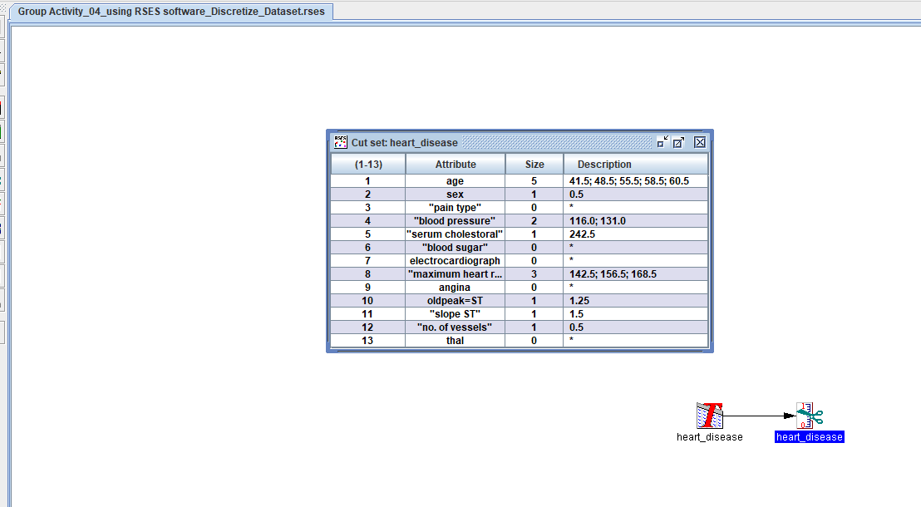

# **DISCRETIZE TABLE SCREENSHOT:**

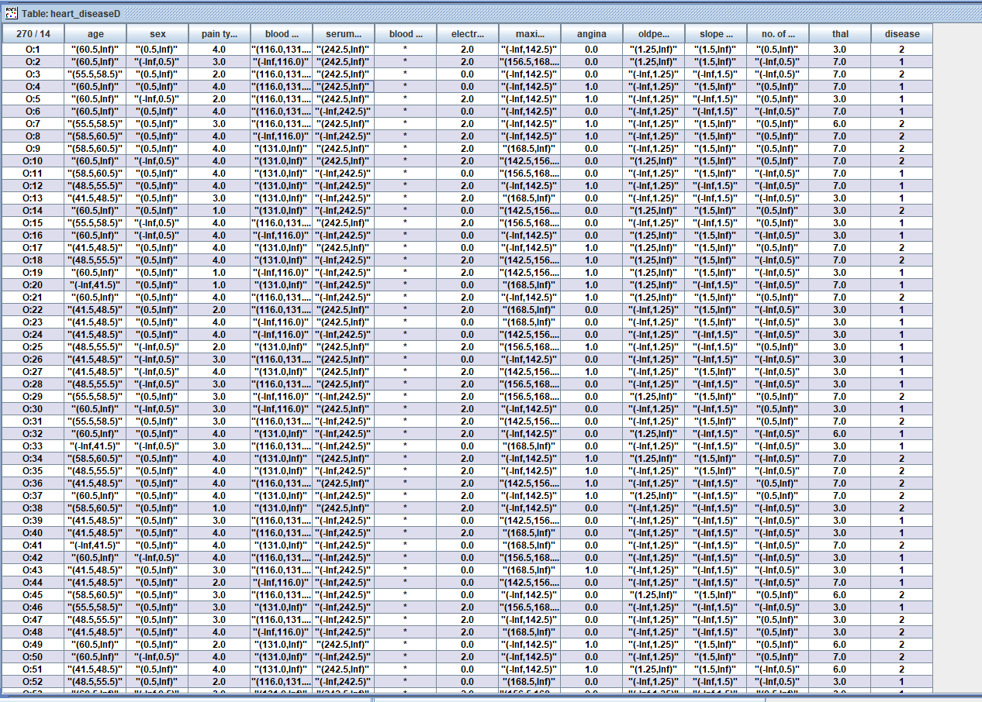

**HISTOGRAM FOR HEART DISEASE:**

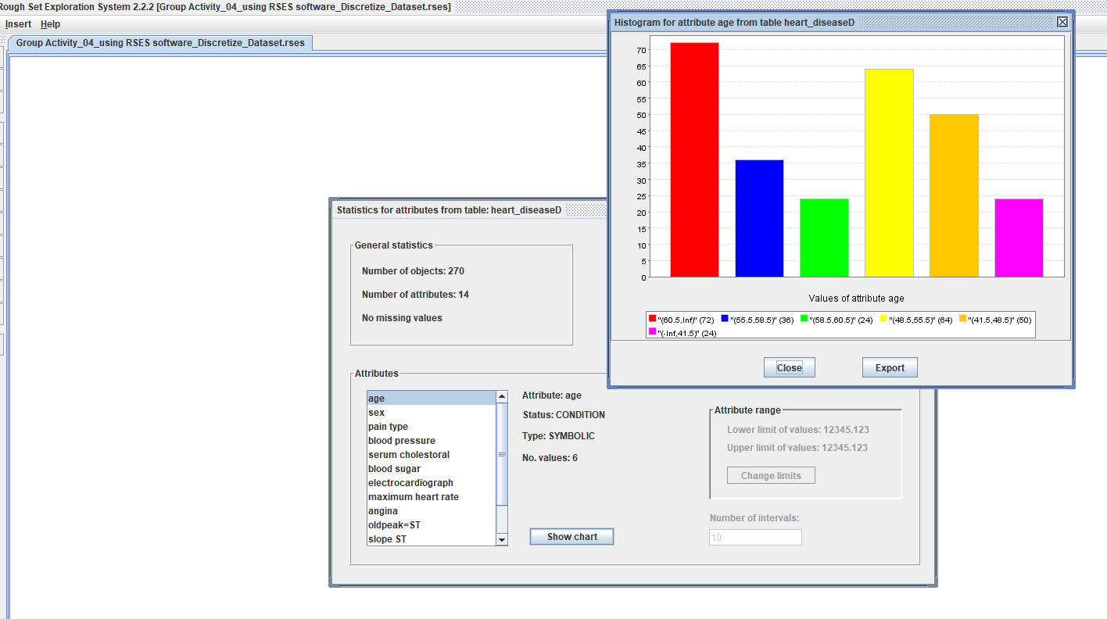

**THE HEART DISEASE DATASET BASED ON THE VALUES OF AGE ATTRIBUTE:**

